Temasek Polytechnic
School of Informatics and IT

Diploma in Information Technology (IT)

AY2013/2014 Apr Semester Level 3

SWEN Assignment 1

Project Particulars

Tutor | Ms Serena Tai
Class | P02
Project Title | Delonix Regia Hotel Management System

Project Team’s Particulars

Matric Number | Student Name
1101387G | Chua Edwin
1101137F | Marvin Koh
1105342H | Leonard Choo

- A short description to explain the meaning of Software Development Life Cycle (SDLC). Do ensure that you include three (3) software development models in your explanation. [5 marks - Group]

SDLC or Software Development Life Cycle, is what goes from a start of a project to the deployment of the software.
SDLC consists of Requirements Engineering, Analysis & Design, Implementation, Testing & Deployment.

There are 3 main models for SDLC.
Firstly, the Waterfall Model. Each of the phase must be completed fully before the next phase can begin in the waterfall model

Second is prototyping, there are 2 types of prototyping:
Throwaway Prototyping
Evolutionary Prototyping

Throwaway Prototyping involves implementing initial requirements that are poorly understood & after showing and validating with the client, a new specification is drawn up and the prototype is thrown away and a new system is built based on the new specification.
Evolutionary Prototyping is developing an initial system that implements parts of the system that are well understood. This system is then shown to the client for comments, after which the system is refined and the process repeats to implement more part of the system until it is complete.

The last model is the unified process or UP.
UP has 4 phases, Inception, Elaboration, Construction & Transition.
Inception is a feasibility study to establish whether the proposed system is worthwhile
Elaboration is about getting a complete list of requirements, design architecture and also develop the project plan and the risk.
Construction is about developing the system
Transition is putting the system into use.

Unified Process uses iteration to accommodate ongoing risk.
Each phase can consist of one or more iterations and each iteration consist of analysis, design, coding and testing.

Terms Of Reference

1. Introduction

Purpose
The project is to develop a hotel management system for Delonix Regia to assist them in managing their customers and to boost their customer traffic.

Background
Despite being in a reasonably good district the hotel is not doing well. This is partly due to a functioning website that is lacking in basic functions like booking of rooms and more.

User and Usage
The users of the system will be customers and tourists. The system will be used for signing-up of an account, reservation and cancelation of a room as well as hotel information. The system will need to be easily understood and have user-friendly functions and interactions. The process cycle for each function will be short and simple and include breadcrumbs so users know where they were previously.

The Hotel has been performing poorly thus the reason to develop a system. This in turn will facilitate the growth of the Hotel to boost its sales positively.

We will also conduct research on other hotel websites to get inspirations on what features we would like the system we’re developing to have.

2. Objectives of the Project

Technical
Creating a Hotel management system that boosts customer traffic and increase revenue for Mr Wang and Mrs Wang.

The system must be capable of being online 24/7 as hotels can have night guests.
Any server downtime must be minimized or have 2 servers for optimum server online time.
One independent server will be used for updating and served as a back-up in cause of the main server being hacked, maintenance required, or it goes down because it turns faulty and a server rollback becomes necessary

The system tailor-made for Delonix Regia must meet or exceed Mr Lim Expectations
The fitness of purpose, the system must meet the functional needs of Delonix Regia.

The system has to be user-friendly to cater to non-IT savvy customer and tourist.

Non-technical
Conduct real life face meeting with Mr and Mrs Wang to update them on the progress of the hotel management system development process.
And conduct a requirement gathering meeting with Mr and Mrs Wang to obtain additional requirement requests

3. Scope of the Project

Login system (Loyalty Program)
Live update – Allows user to:
- Check availability of rooms
- Make room bookings
- Check booking status
- Cancel existing bookings
Customer compatibility - Matches a room class, room view and room level depending on user’s budget and user’s preference)

4. Distribution of Workload

Objectives/Deliverables | Members
1,2 | Leonard
3,7,8 | Marvin (Leonard did Cus Comp System)
5,6 | Edwin
4 | All
Project Plan | Members
1,2 | Edwin
3 | Marvin
4 | Leonard
3.2 | All

5. Constraints

Personal Laptops not configured properly to SQL database.
Lab opening hours due to usage of school workstations

6. Resources

Hardware:
Personal Laptops / School Workstations

Software:
Word Processing Software (E.g Microsoft Word)
Visual Studio 2010/2012
Web Broswer (E.g IE, Mozilla, Chrome)
SQL Server Management Studio
Online Cloud Storage (E.g Dropbox, Google Drive, Skydrive)

7. Product Positioning in the Market/Company

- Does not require a third-party booking system (e.g. Asiarooms.com, Expedia.com.sg, Zuji.com.sg)
- Will have constant software updates/bug fixes in response to users’ feedback on the app – we aim to be a 5-star app that will not disappoint our user.

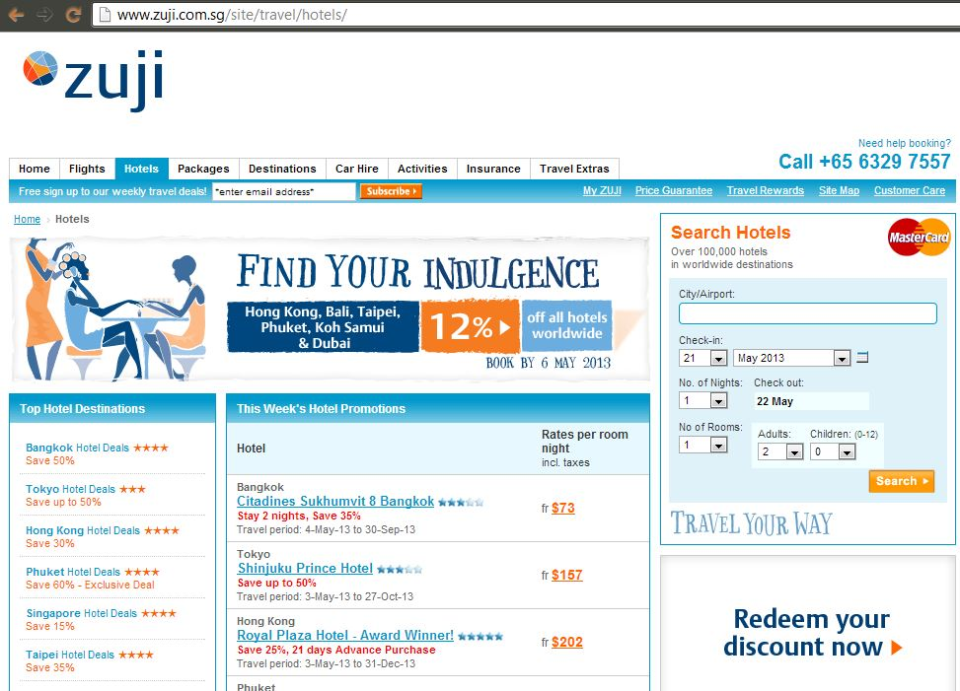
Details are very vague.

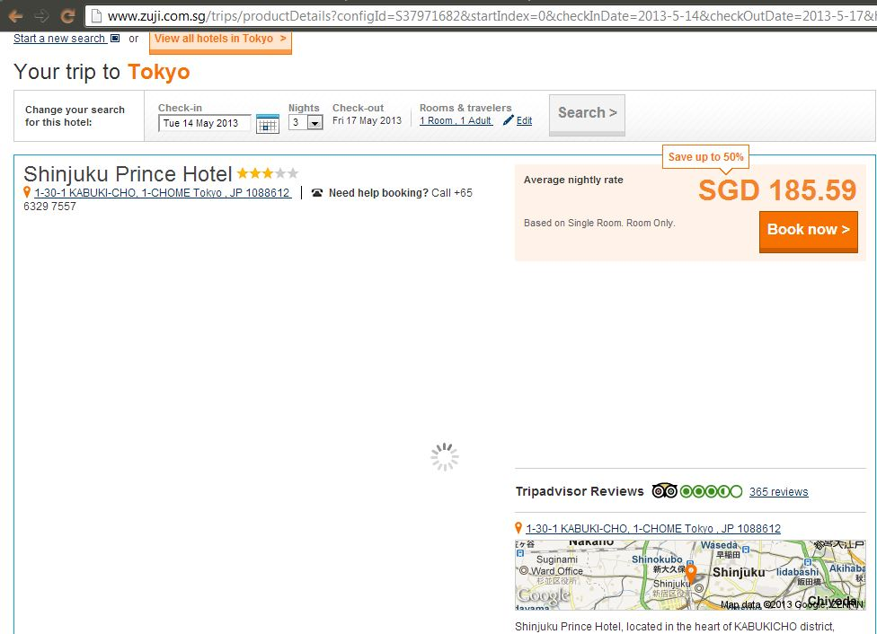
Details on hotel are brief.

8. Approach and Methodology of the Project

Unified Process
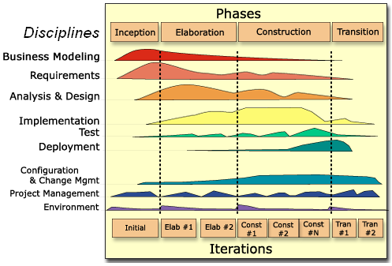

Project Plan

Revision History

Date | Version | Description | Author
07.05.2013 | 1.0 | First Creation | Chua Edwin

Table of Contents

- Introduction
  - Objectives and scope of the project
  - Assumptions and constraints
  - Definitions and acronyms

- Roles and responsibilities

- Estimates and project schedule
  - Work breakdown structure
  - Project schedule
  - Budget summary

- Risk management plan
Project Plan

1 Introduction
1.1 Objectives and scope of the project

The objectives of this project are to develop a hotel management system for Delonix Regia to assist them in managing their customers and to boost their customer traffic.
A few features that this project is expected to deliver is:
- A login in & Loyalty program system for customers to create an account.
- A live update system, where users are able to check the availability of the rooms, make bookings, check the booking status and cancel exisiting bookings.
- Customer’s compatibility checking – Rooms will be offered to customers based on their budget and preferences.
The project is expected to deliver a functional hotel management system web service that will incorporate the features mentioned above.

1.2 Assumptions and constraints

Assumptions:
A functioning website exist, but lacking in basic functions such as booking of rooms and more.
Any functions proposed is not final, as Mr and Mrs Wang have not decided on the final features that they want.
Constraints:
Personal Laptops not configured properly to SQL database.
Lab opening hours due to usage of school workstations.
Software only usable and available on School VDI.

1.3 Definitions and acronyms

VDI – Virtual Desktop Infrastructure (Vmware)
SQL – Structured Query Language

2 Roles and responsibilities

Live update – Marvin
Login System & Loyalty System – Edwin
Customer Compatibility – Leonard
Database and Features Integration - Everyone

3 Estimates and project schedule

3.1 Work breakdown structure

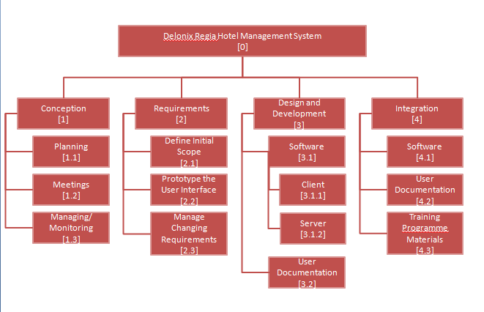

*Calculate budget required to complete development of application and foresee budget required to maintain application.

  - Project Schedule

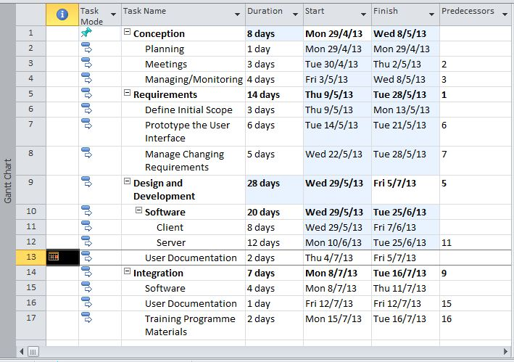

3.3 Budget Summary

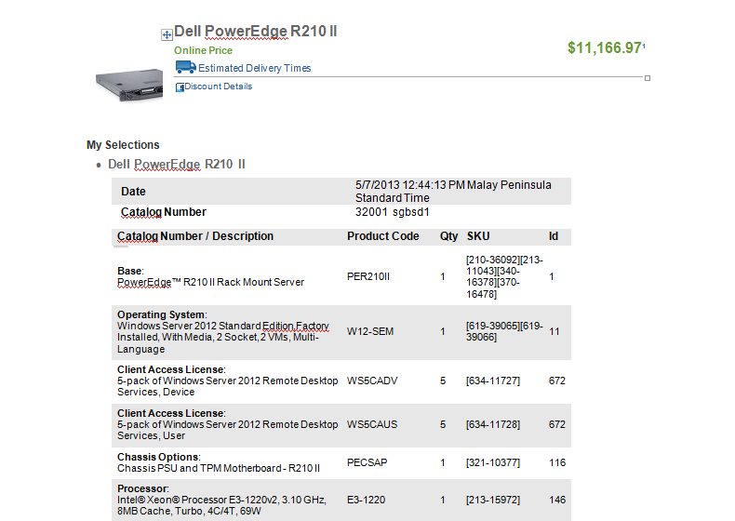

4 Risk Management Plan

- A) Exceeding the budget
- B) Exceed allocated time schedule
- C) Requirements of project change
- D) Failure to deliver expected work

- A) Exceeding the budget
- Some strategies to prevent this
- If our team exceeds the budget we could renegotiate with the investors for a greater allowance or minimize cost in certain tasks by reworking them so as to allocate the resources saved to other tasks. This extends the budget for other use.
- Risk Avoidance
- To prevent this we could plan in detail and plan with consideration on how to solve the problems. Having the problems in mind while planning sets a motion which when thinking of ideas helps to think of solutions and when unnecessary ideas which could result in conflict are thought of they will not be given further thought but be thrown out. This save effort and allow them to concentrate on planning

- B) Exceed allocated time schedule
- Some strategies to prevent this.
- Fast tracking
- Working in parallel this allows several or more things to be done at a time. This allows the activities in the schedule to be completed on time and according to the schedule

- C) Requirements of the project changes
- Some strategies to resolve this
- Crashing
- Allocating more resources to the project. Resources such as people to work on the project this however is costly. This creates the possibility to edit the project faster and make changes to the project which will satisfy the new requirements
- If the new requirements prerequisites would make necessary our team to possess skill sets that our team lacks and it is far too late to make modifications or employ
- Additional help.
- Risk mitigation an action we can undertake is renegotiate
- By renegotiating with the project owners we can offer substitutions and work out a solution without compromising quality (example. Project requires strawberries but not in season opt to use grapes instead)

- D) Failure to deliver expected work
- If the work delivered is not up to expectations. Due to unforeseen circumstances. Such as the loss of project files or corruption of project files
- Some strategies to prevent this
- Plan Contingency
- By having a Plan B having a backup of the saved project files on a thumb drive or hard drive, install an anti-virus to prevention corruption of project files we can obviate to be ready or prepared in case of the occurrence of scenarios which cause failure of the deliverables.

Type of Risk | Severity of Impact | Likelihood of Occurrence | Risk Exposure
A) Exceeding the Budget | High | Medium | 6
B) Exceed allocated time schedule | Medium | High | 6
C) Requirements of the project changes | High | Low | 3
D) Failure to deliver expected work | High | Low | 3

Risk | Risk category?
Exceeding the budget | Project
Exceed allocated time schedule | Project
Requirements of the project changes | Project
Failure to deliver expected work | Technical

